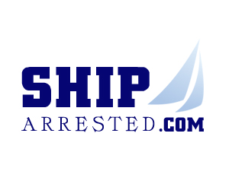 | 9th MEMBERS’ MEETING  NYC, 2-3 MAY 2012  hosted by  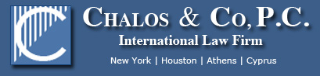

Wednesday 2 May 2012
18.30 – Dinner cruise around Manhattan - The name of the ship is “RESPECT” and you can meet her at Pier 40 in NYC which is at West Houston Street and the West Side Highway. Boarding begins at 1800 hour.

Thursday 3 May 2012
Registration opens at 8h30

09:00 - Opening address
Valentine de Callatay, www.shiparrested.com network

09:30 – Guests addresses
Captain Thomas F. Fox, NY Society of Martime Arbitrators
Alan Swimmer, National Marine Liquidators
Nicholas Himonidis, T&M Protection Resources, LLC

10:30 – International Panel Discussion: whether Arbitration/litigation is
preferred… Chaired by Richard Faint, Arbitrator, Charterwise Ltd.
with George M. Chalos (US), Brian Taylor (UK), John Harris (Israel) and
V.K. Ramabhadran (india)

11:30 – Coffee Break

12:00 – Arrest procedures: important legal changes in:
*Panama by Francisco Carreira-Pitti, Partner, Carreira-Pitti PC Attorneys
*Russia by Leonid Gribanov, Maritime Bureau - Law Firm
*Ukraine by Vagif Mallayev, Partner, Lexcellence
*New Turkish Arrest Rules. by Zeynep Özkan, Partner, Özkan Law Office

13:00 - Conference Lunch

14:30 – Practical aspects on planning the arrest
Christian Hernandez, Partner, ISOLAS, Gibraltar

15:00 – Arrests Procedures: Arrest procedures: new papers at shiparrested.com:
*Korea by Dong-Hee Suh, Partner, Suh & Co
*Canada and the province of Quebec: recourses available to claimants against
the Ocean Carrier, by Marc de Man, Partner, De Man Pilotte
*Mortgage, Necessaries and Good Faith, by Merav Nur, Naschitz, Brandes&Co

16:30 – Coffee Break

17:00 - International Panel Discussion on Post Arrest
Chaired by Peter van der Velden, Partner, Kiveld, Netherlands
with Brad F. Gandrup (US), Thomas Wanckel (Germany), Henri Najjar (France),
Takayuki Matsui (Japan), Henri Feh (Cameroon)

18:00 - closure of the conference

19:00 – Conference dinner

